CREATE AN RDS CONNECTION WITH EC2 INSTANCES AND USE IT TO CREATE AN SQL DATABASE AND A SAMPLE TABLE

1. Sign in to the AWS Management Console and open the Amazon RDS console at <https://console.aws.amazon.com/rds/>.
2. In the upper-right corner of the Amazon RDS console, choose the AWS Region in which you want to create the DB instance.
3. In the navigation pane, choose Databases.
4. Choose create database, then choose standard create.

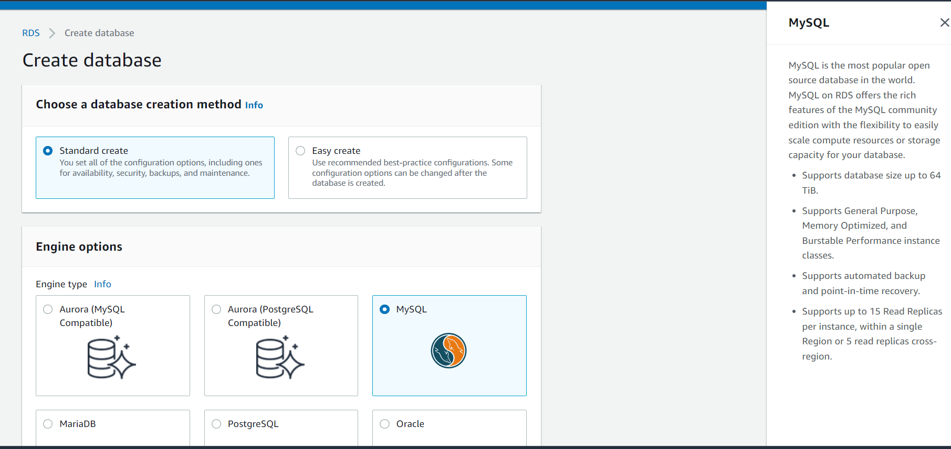

1. For engine type, choose MariaDB, Microsoft SQL Server, MySQL, Oracle, or PostgreSQL.
2. Select MYSQL option.
3. Go to engine version and select the version of MYSQL 8.0.28.

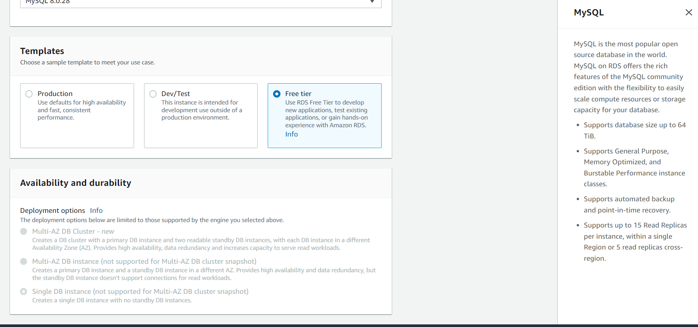

1. Go to Templates and select Free tier. By selecting this free tier option no charge is allowed for usage.
2. Go to settings.

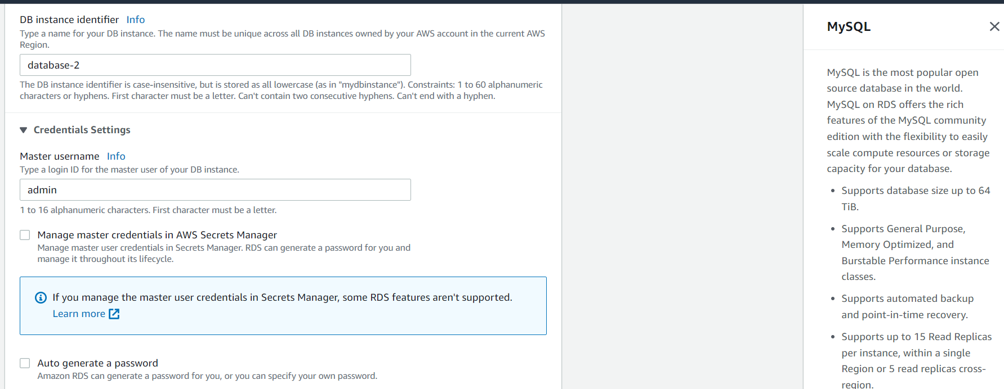

1. In settings the DB instance identifier is shown default.
2. From the credential settings, the master username is given as admin by default.
3. The master password is set by us or we can select auto generate a password.

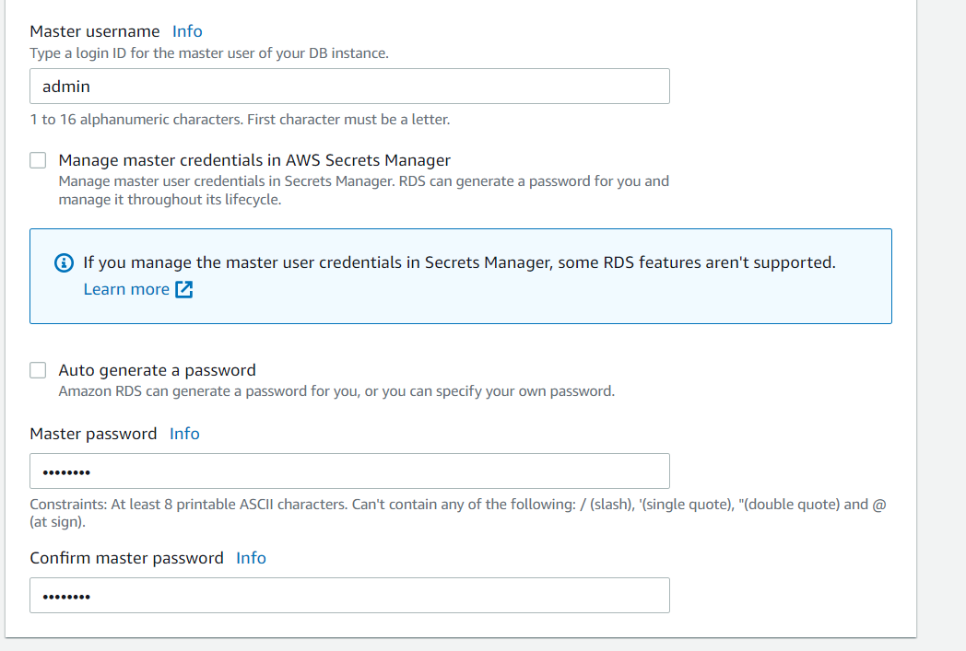

1. After typing the master password confirm password.
2. Go to connectivity and create a new security group and add a new security group name.

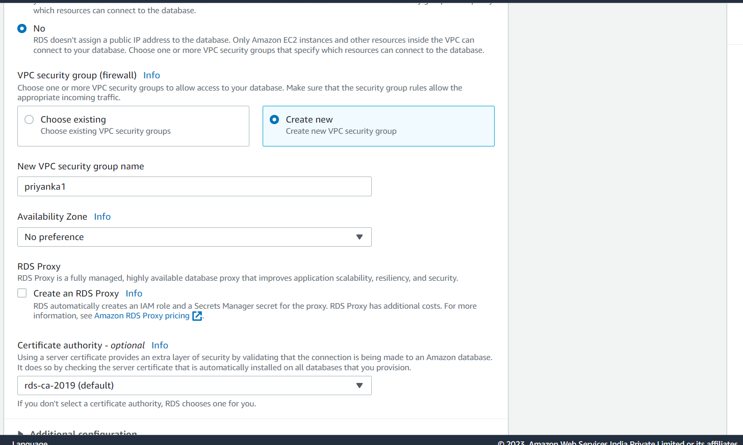

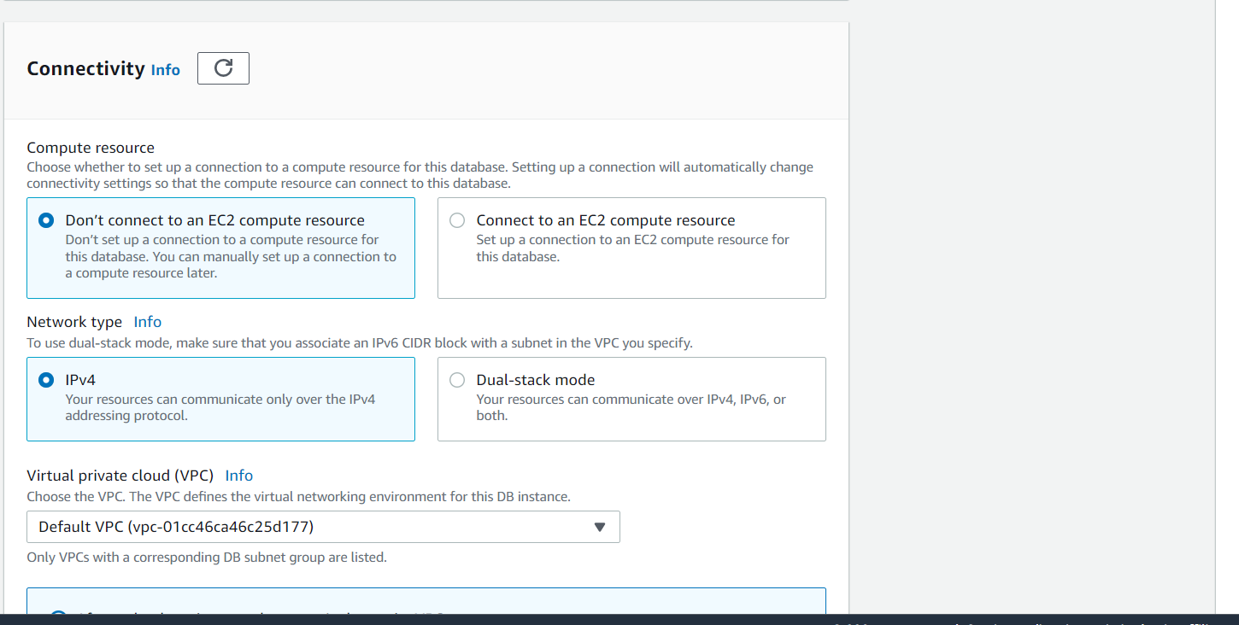

1. Remaining settings are set default and create the database.

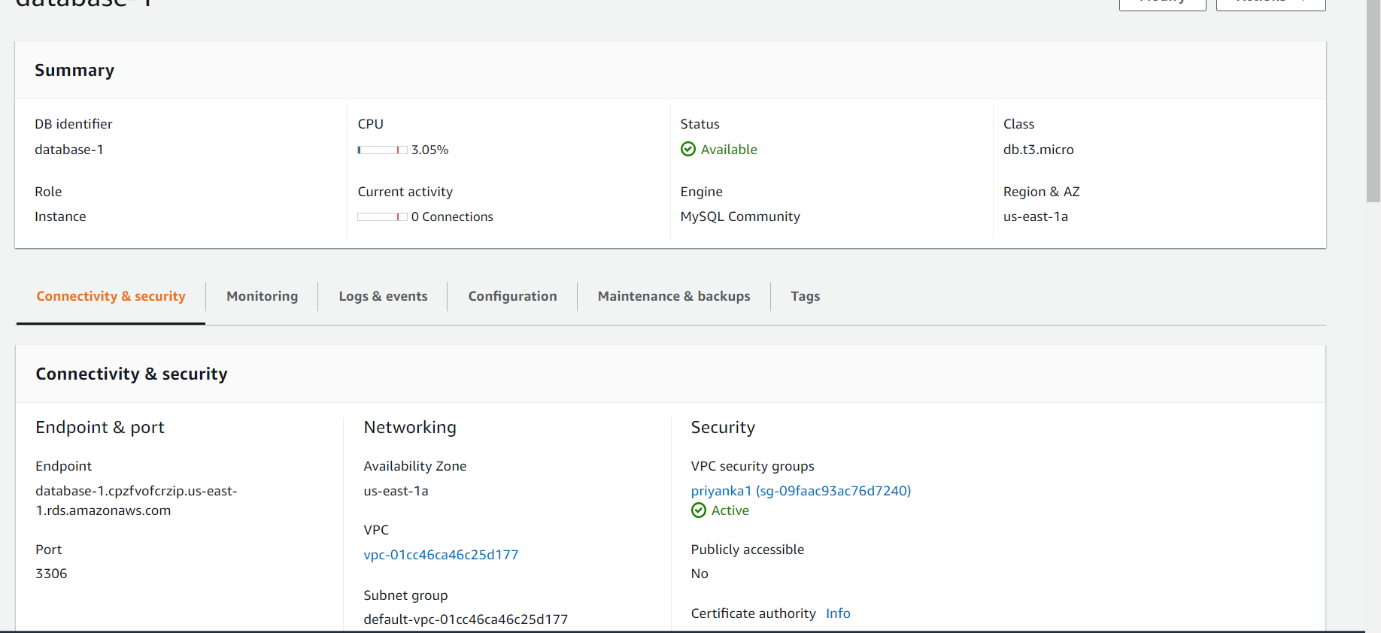

1. After creating the database the endpoint appears and also status appears as available.
2. Open the Amazon EC2 console at <https://console.aws.amazon.com/ec2/>.
3. Choose Launch instance
4. Choose Amazon machine image find ubuntu at the top of the list and choose select.

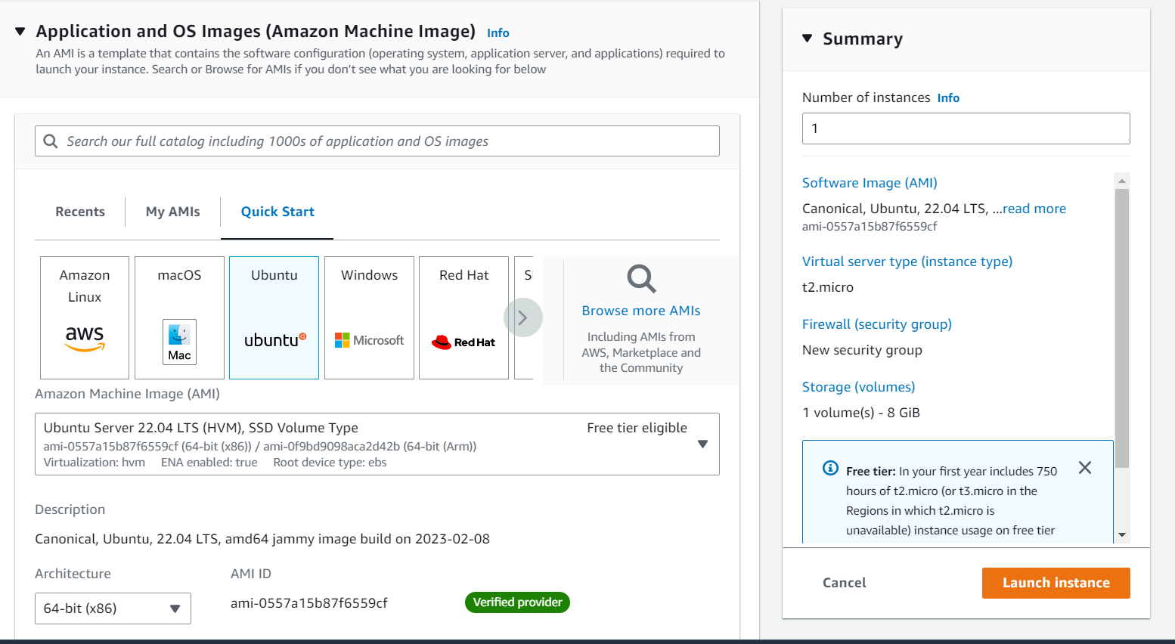

1. Choose as instance type as t2 micro which is free tier eligible.

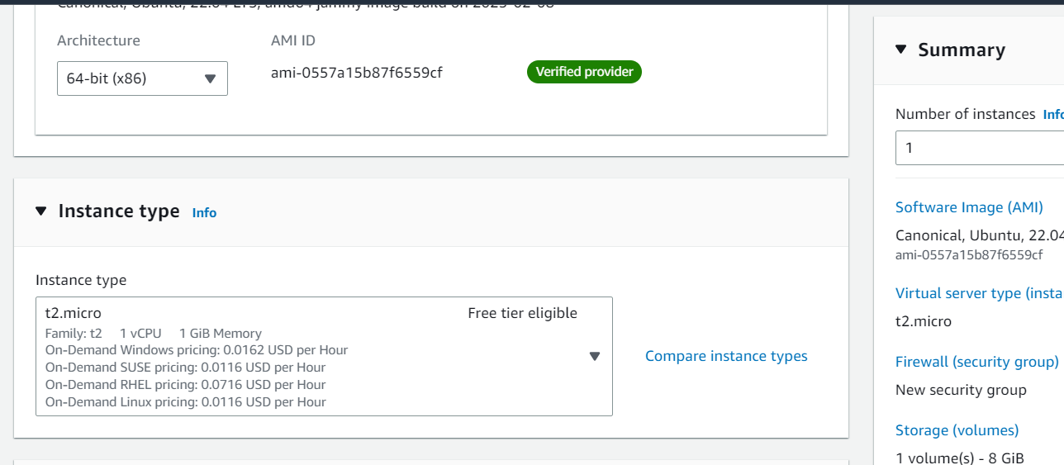

1. Select the existing key pair or create a new key pair.

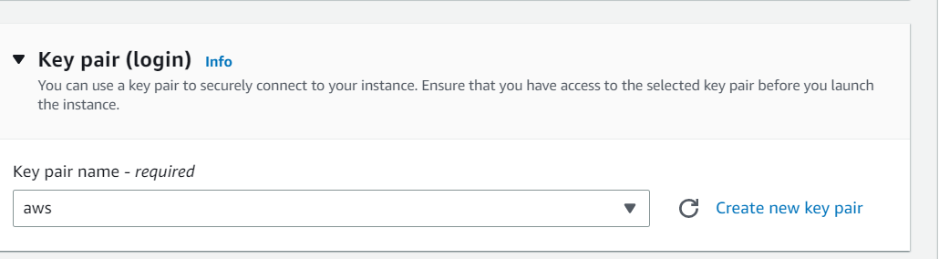

1. Go to network settings and select the existing security group where we have created in rds.

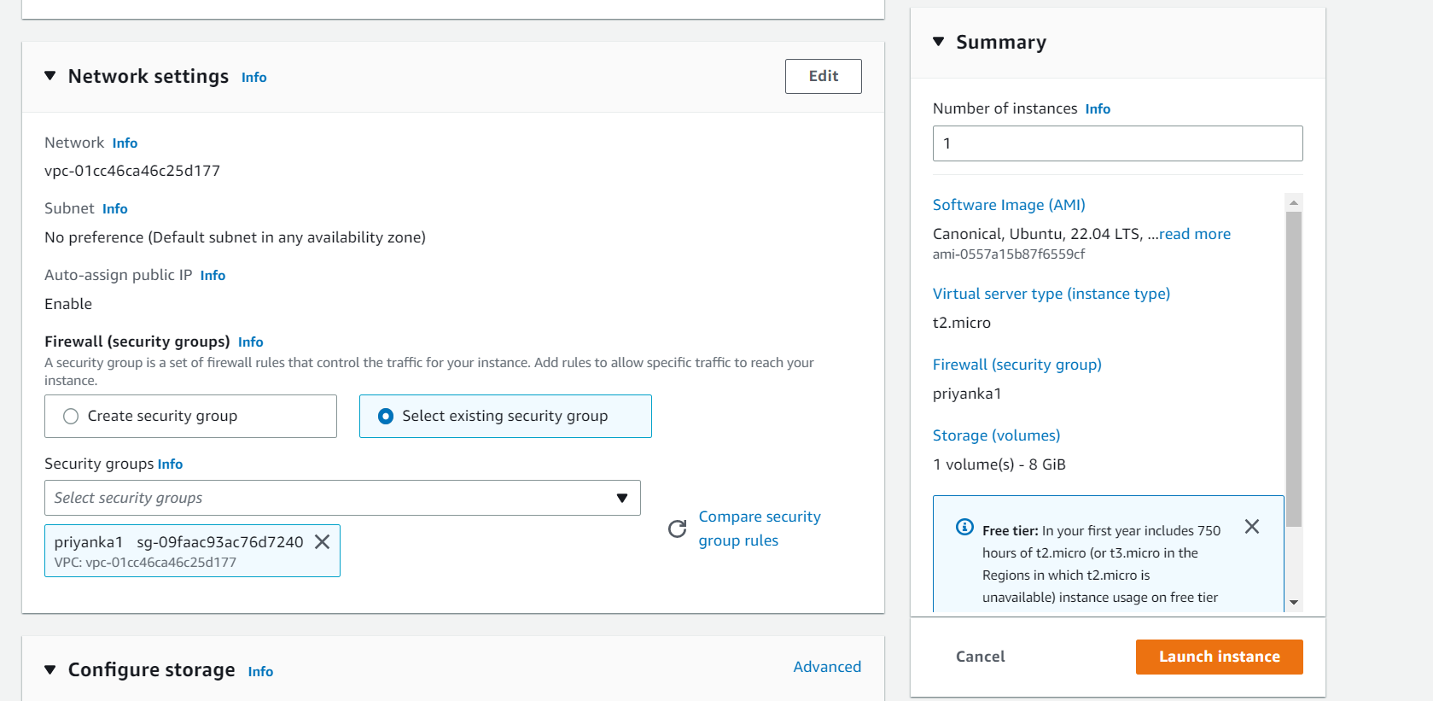

1. Remaining settings are set by default.
2. Now, launch the instance.

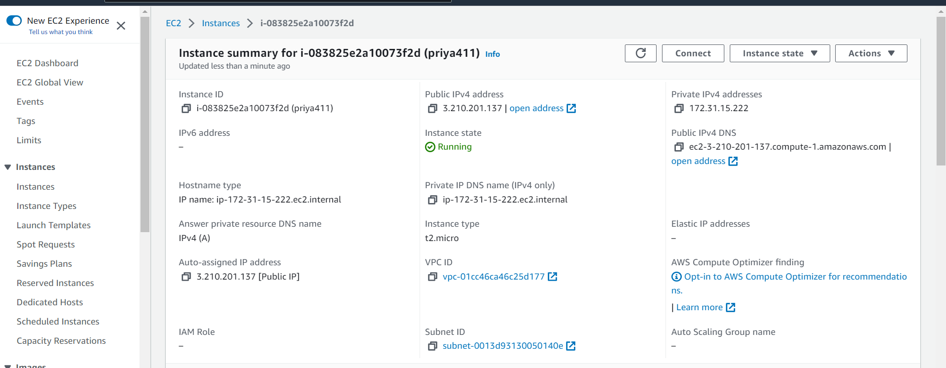

1. After running the instance then go to security settings and go to inbound rules.

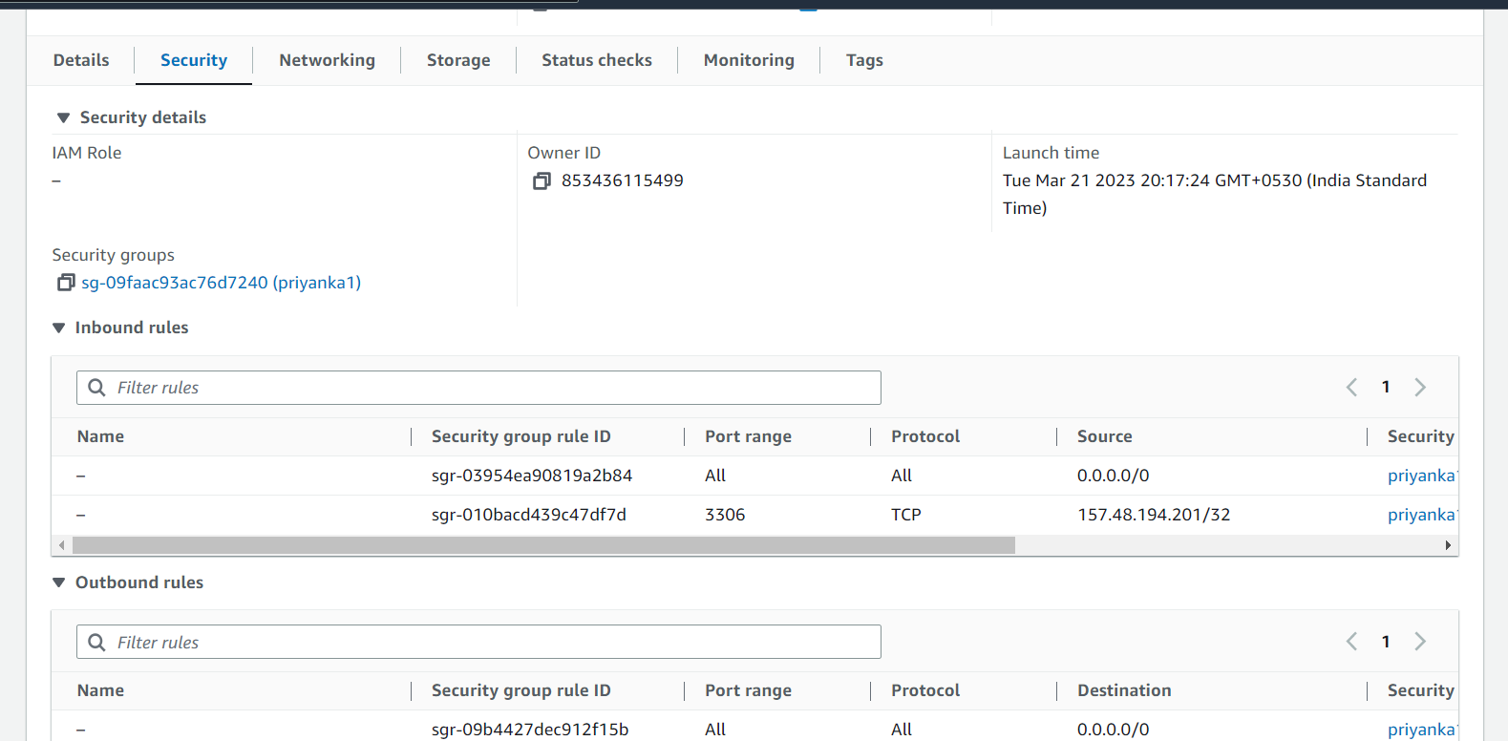

1. Add rules in inbound rules.

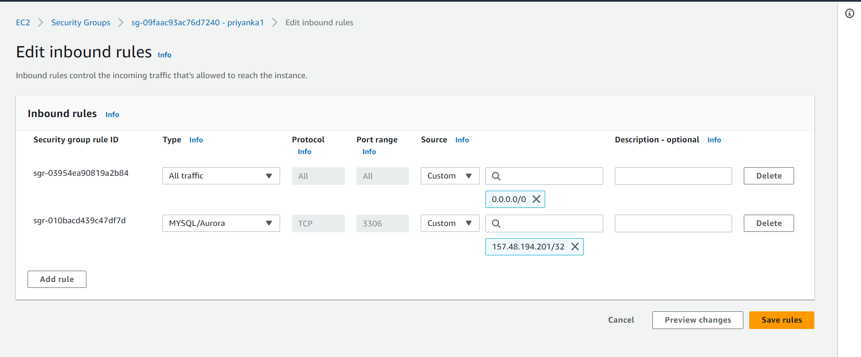

1. Save the changes
2. Now connect the ec2 instance.

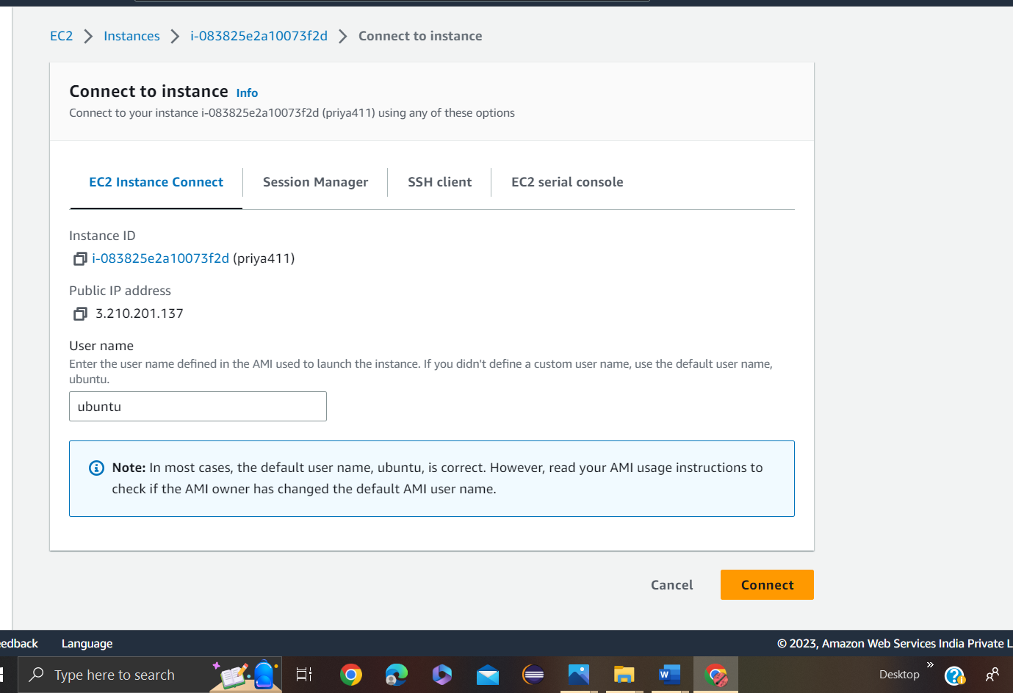

1. Type the following commands.
2. Sudo su
3. apt-get install mysql-client
4. y/n-- >y
5. mysql -h <RDSendpoint> -P 3306 -u admin -p
6. password
7. CREATE DATABASE,database_nhame>;
8. USE <database_name>;
9. CREATE TABLE <tablename> (id INT NOT NULL AUTO_INCREMENT,name Varchar(50)NOT NULL,PRIMARY KEY(ID));
10. INSERT INTO <tablename> (name)VALUES(‘your name’)
11. SELECT * FROM <tablename>
12. A new sql table is created.

